Hands-On Test 1

Ahmed Mohammed

First Activity Screen(AhmedActivity.kt)

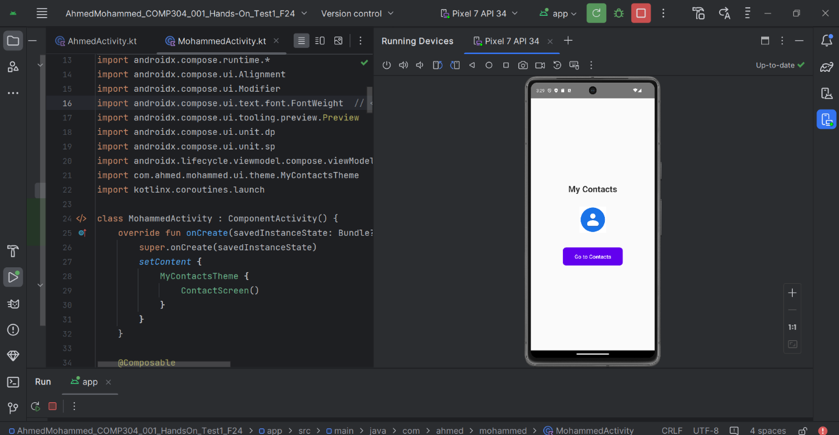

Second Activity Screen(MohammedActivity.kt)

